Worksheet No. - 6

Student Name: Sujal Dhiman UID: 25MCA20186
Branch: MCA Section/Group: 1A
Semester: 2nd Date of Performance: 17/02/2026 Subject Name: TECHNICAL TRAINING Subject Code:25CAP-652

Aim/Overview of the practical:
Learn how to create, query, and manage views in SQL to simplify database queries and provide a layer of abstraction for end-users.
Objective:
- Data Abstraction: To understand how to hide complex table joins and calculations behind a simple virtual table interface.
- Enhanced Security: To learn how to restrict user access to sensitive columns by providing views instead of direct table access.
- Query Simplification: To master the creation of views that pre-join multiple tables, making reporting easier for non-technical users.
- View Management: To understand the syntax for creating, altering, and dropping views, as well as the naming conventions required for efficient data access.
Theory:
A View is essentially a virtual table based on the result-set of an SQL statement. It does not contain data of its own but dynamically pulls data from the underlying "base tables".
- Simple Views: Created from a single table without any aggregate functions or grouping. These are often updatable.
- Complex Views: Created from multiple tables using JOINs, or including GROUP BY and aggregate functions. These provide a consolidated summary of the database.
- Security Layer: In enterprise environments, views are used to grant permissions on specific subsets of data. For example, a "SalaryView" might exclude the "Employee_SSN" or "Home_Address" columns for privacy.
- Benefits: They simplify the user experience, ensure data consistency across reports, and reduce the risk of accidental data modification by providing read-only abstractions.

Input/Apparatus Used:
- Oracle
- MS SSMS
- PostgreSQL
Procedure/Algorithm/Code :
CREATE TABLE employees (
emp_id SERIAL PRIMARY KEY,
emp_name VARCHAR(50),
department VARCHAR(50),
salary INT
);

INSERT INTO employees (emp_name, department, salary) VALUES
('Amit', 'IT', 60000),
('Riya', 'HR', 45000),
('Sohan', 'IT', 70000),
('Neha', 'Finance', 40000);

-- create view for IT employees
CREATE VIEW it_employees AS
SELECT emp_id, emp_name, salary
FROM employees
WHERE department = 'IT';

-- query the view
SELECT * FROM it_employees;

-- update data using view
UPDATE it_employees
SET salary = salary + 5000
WHERE emp_id = 1;

-- create view for high salary employees
CREATE VIEW high_salary AS
SELECT emp_name, department, salary
FROM employees
WHERE salary > 50000;

-- query second view
SELECT * FROM high_salary;

-- create read-only view
CREATE VIEW readonly_view AS
SELECT emp_name, salary
FROM employees
WITH CHECK OPTION;

-- drop view
DROP VIEW it_employees;

Output:

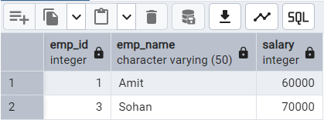
It_employees view

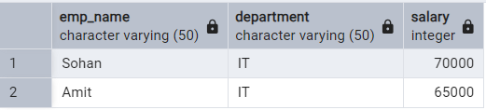
High_salary view

Learning outcomes (What I have learnt):
- Abstraction Proficiency: Students will be able to create and query views to simplify efficient data access and abstraction.
- Security Implementation: Students will understand how to use views for data masking and providing restricted access to sensitive information.
- Syntactic Accuracy: Students will demonstrate the correct syntax for creating and querying views, ensuring logical clarity in naming conventions.
- Real-world Application: Students will be able to design views for practical domains like Library Management Systems or Payroll Systems to demonstrate functionality.

